Course: Artificial Intelligence
Course Code: DSA 2020
Lecturer: prof. Edward Ombui
Name: Aleke James
Cynthia Njoki
Rule-Based Expert system for maize crop diagnosis

Introduction
Agriculture is a key sector in Kenya, with maize being one of the most important staple crops. However, farmers often face challenges such as drought, pest infestation, and nutrient deficiencies, which negatively impact crop productivity. In many rural areas, access to agricultural experts is limited, making it difficult for farmers to diagnose crop problems early.
This project develops a rule-based expert system that helps diagnose maize crop conditions using environmental and crop-related data. The system mimics the reasoning of an agricultural expert by applying predefined rules to provide diagnosis and recommendations.

Problem statement
Smallholder farmers often lack access to expert knowledge required to identify crop diseases and environmental stress factors. As a result, crop damage may go unnoticed until it becomes severe.
This project aims to diagnose maize crop health conditions, identify causes such as drought stress and damage levels, and provide simple recommendations to farmers.

Objectives
To develop a rule-based expert system for diagnosing maize crop conditions.
Specific Objectives
- Analyze agricultural data related to maize crops
- Create a knowledge base using IF-THEN rules
- Implement a system that provides diagnosis and recommendations
- Test the system using real-world data

Data source
The project uses data derived from the Lacuna agricultural dataset, which contains information about maize crops in different regions of Kenya such as Kanduyi, Machakos, and Budalangi.
The dataset includes drought probability, drought extent, crop damage (extent), growth stages, and environmental disturbances. This data reflects real agricultural conditions and was used to develop rules for diagnosing crop health.

Knowledge Base and rule base
The rule base was developed by analyzing patterns in the dataset. High drought probability and extent are associated with unhealthy crops, while low drought values and zero damage indicate healthy crops. These observations were converted into rules used by the expert system.
IF damage = G and extent <=0.5 THEN healthy maize
IF damage = DR and drought> 0.1 THEN severe drought stress
IF damage = DS THEN disease symptoms detected
IF damage = WD THEN Weed disturbance
IF damage = PS THEN Pest stress
Examples of rules:
- IF drought probability > 0.7AND drought extent > 50 THEN extreme drought stress
- IF drought_probability > 0.5 AND drought_extent > 30 THEN severe drought stress
- IF drought_probability > 0.3 AND drought_extent > 20 THEN moderate drought stress
- IF extent == 0 AND drought_probability < 0.05 THEN crop is healthy
- IF extent > 70 THEN crop is critically damaged
- IF extent > 50 THEN crop is severely damaged
- IF extent > 20 THEN crop has moderate damage
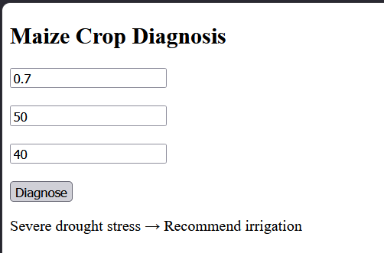

System implementation and Inference Engine
The system uses forward chaining, where user inputs are treated as facts and rules are applied to produce a diagnosis using HTML for the user interface and JavaScript for rule-based logic. Users enter input values and receive instant diagnosis.

Limitation
- Uses fixed rules
- Cannot learn from new data
- Limited to predefined conditions
Conclusion
The project successfully developed a rule-based expert system for diagnosing maize crop conditions based on environmental indicators and demonstrates the usefulness of rule-based AI in agriculture.

